Summer 2020

8 Week Velocity Build Program



## Questions You Will Ask

##### Who Should do this program?

This program is designed for physically mature players ages 14 and up. As a general guideline, we recommend this program for players with a foundation of throwing and a general understanding of throwing mechanics. If you are younger than 14 or have had recent injuries and/or have not been medically cleared for throwing activities DO NOT do this program. Continue your prescribed program from your licensed physical therapist. It cannot be stressed enough, do not skip a program created by a doctor or physical therapist in favor of starting this velocity build program.

##### Are weighted balls dangerous?

More and more research is available and supports the notion that throwing **UNDERWEIGHT** or lighter balls presents a higher injury risk than throwing overload or heavier balls. It is for this reason that much of the programming you will find in this guide is overload progressions mostly performed at submaximal intent levels. We introduce the underload balls much later in the programs in small increments because, despite the increased injury risk, underload throws have also shown to have a positive impact on arm speed development. The risk associated with underload balls needs to be evaluated on a case by case basis. Listen to your arm, it will tell you.

##### Where do I start?

It is very important that you understand that unless you have completed the in-season segment of the weighted ball throwing program you MUST start and complete the ON RAMP segment of this guide. If you did complete the Velo Lab In-Season Velocity Maintenance program then proceed directly to the Velocity build segment of this guide. It cannot be stressed enough, DO NOT SKIP THE ON RAMP!!!!!!

## In Case You Are New to Weighted Ball Training

We understand that misconceptions and controversy that surrounds weighted balls and weighted ball training. A large part of the of the associated fear comes from poor training programs or implementation. The two most common mistakes made in programming is too much weighted ball throwing volume and lack of proper pre and post throwing care.

Across multiple sports research continues to show that the use overweight and underweight implements is a proven way to improve an athlete’s efficiency of movement and their ability to produce and accept force. Because of misguided perceptions and misunderstandings in implementation they are still shunned by many in the industry mainly due to lack of understanding of their value and importance to the athlete's development.

This is not intended to be as step by step guide to give you mechanical literacy but rather using proven methods to passively nudge you in the direction of finding your most optimal movement solution. Everyone is different. Different shapes, different sizes, and different movement profiles. Therefore, it is incomprehensible to think that one perfect throwing mechanical model exists.

# The Process

Finding an athlete's most optimal movement solution or trying to affect change and remap poor movement patterns is a more complicated process than simple cues or conventional methodology. What tends to happen using this method is that in noncompetitive low-stress environments the athlete can make short, false improvements but it all falls apart once the game or competition begins because we have not rooted the movement on a deeper level. We will facilitate an environment in which mechanical change can now happen by breaking up the parts of the pitching delivery and applying constraints to those parts. The constraint methods will work from most constraint to least constrained encouraging the athlete to solve the external intent within the mechanical framework that we will discuss in the next section.

Constraint-led coaching is very much an advocate of hands-off coaching, with the coach as guide or facilitator. Coaches should not force all athletes to try to fit into a perfect movement template often highlighted in many textbooks as the one way of performing a movement. In general, if the biomechanics principles of the movement are sound and the movement is not going to cause injury, good coaches allow their athletes to solve problems in ways that are best suited to their own individual movement profiles. The critical point for coaches is to encourage athletes to solve problems using techniques that are most suitable for them individually.

According to the principle of self-organization under constraints, coaching must be more hands-off than it would be under a traditional approach. Providing learners with

opportunities to discover solutions rather than ‘prescribing’ answers is a basic tenet of constraints coaching. This approach creates a learning environment that facilitates exploratory behavior and self-discovery via natural subconscious learning of movements rather than using explicit instructions that would encourage players to analyze their own internal movement.

## Suggested Equipment

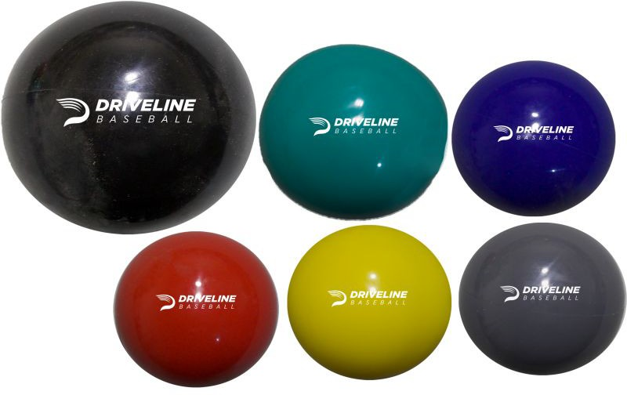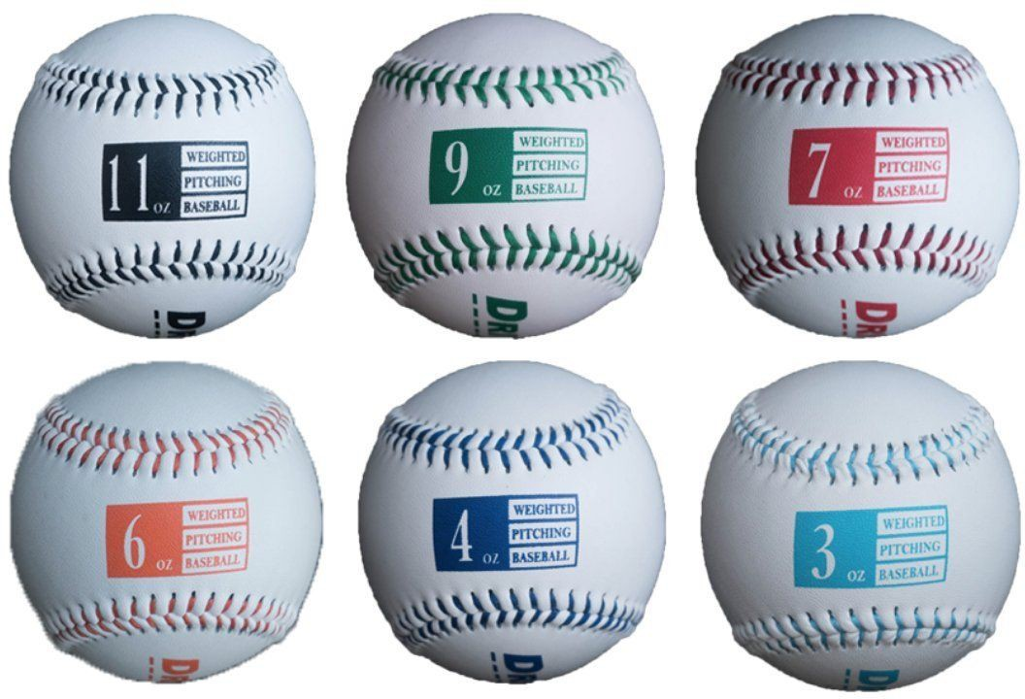

#### [Driveline Plyocare Balls](https://amzn.to/2jNTJrp) Driveline Weighted Baseballs

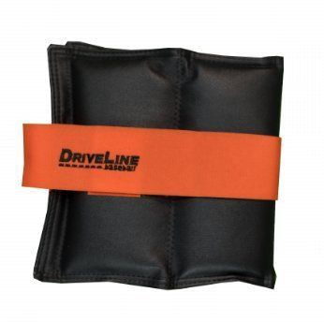 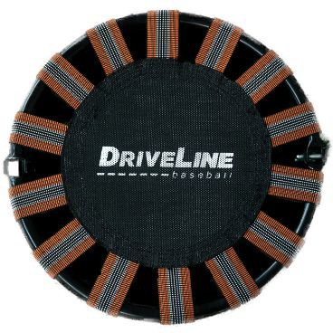

#### [Driveline Wrist Weight Set](https://amzn.to/2KRwklp)

[**Driveline Recovery Trampoline**](https://amzn.to/2KQapeh)

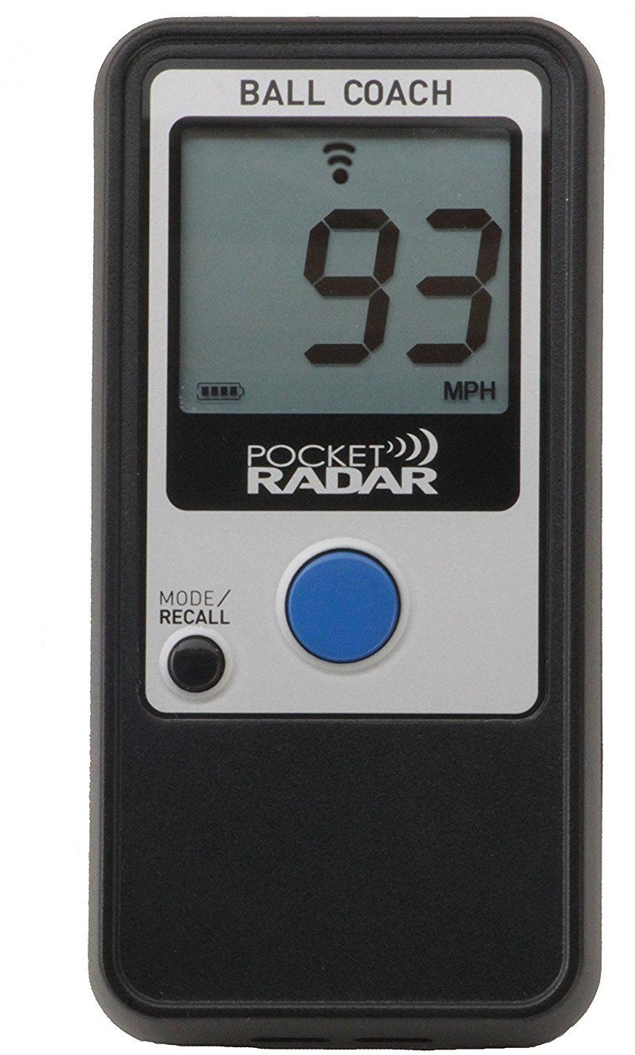 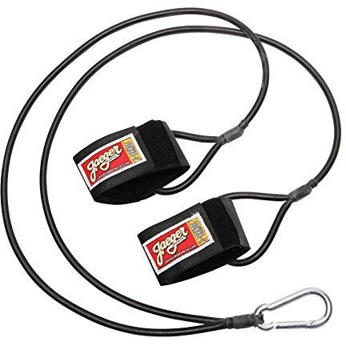

#### [Pocket Radar](https://amzn.to/2G4HS0N) [Jaeger Bands](https://amzn.to/2rAMPtd)

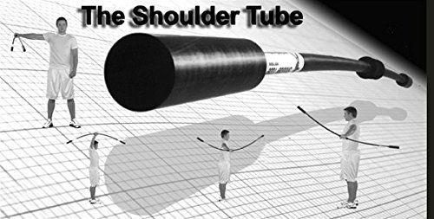

[**Taps Shoulder Tube**](https://amzn.to/2wC2RZo)

8 Week On Ramp

Player has not thrown any weighted balls and needs to on ramp to improve overall arm fitness levels

##### Day Schedule

|  |  |  |  |  |  |  |  |
| --- | --- | --- | --- | --- | --- | --- | --- |
|  | Day 1 | Day 2 | Day 3 | Day 4 | Day 5 | Day 6 | Day 7 |
| Week 1 | Velocity A | Off | Off | Heavy Hybrid A | Off | Off | Off |
| Week 2 | Heavy Hybrid A | Off | Off | Heavy Hybrid A | Off | Off | Off |
| Week 3 | Heavy Hybrid B | Off | Off | Heavy Hybrid B | Off | Off | Off |
| Week 4 | Heavy Hybrid A | Off | Off | Velocity B/C | Off | Off | Off |
| Week 5 | Heavy Hybrid A | Off | Off | Light Hybrid B | Off | Off | Off |
| Week 6 | Light Hybrid A | Off | Off | Light Hybrid B | Off | Off | Off |
| Week 7 | Heavy Hybrid B | Off | Off | Light Hybrid A | Off | Off | Off |
| Week 8 | Light Hybrid A | Off | Off | Velocity B/C | Off | Off | Off |

1. **Day Schedule**

|  |  |  |  |  |  |  |  |
| --- | --- | --- | --- | --- | --- | --- | --- |
|  | Day 1 | Day 2 | Day 3 | Day 4 | Day 5 | Day 6 | Day 7 |
| Week 1 | Velocity A | Off | Heavy Hybrid A | Off | Heavy Hybrid A | Off | Off |
| Week 2 | Heavy Hybrid A | Off | Heavy Hybrid A | Off | Heavy Hybrid B | Off | Off |
| Week 3 | Heavy Hybrid B | Off | Heavy Hybrid A | Off | Heavy Hybrid B | Off | Off |
| Week 4 | Heavy Hybrid B | Off | Heavy Hybrid A | Off | Velocity B/C | Off | Off |
| Week 5 | Heavy Hybrid A | Off | Light Hybrid B | Off | Light Hybrid A | Off | Off |
| Week 6 | Light Hybrid A | Off | Heavy Hybrid A | Off | Velocity B/C | Off | Off |
| Week 7 | Heavy Hybrid B | Off | Light Hybrid A | Off | Light Hybrid B | Off | Off |
| Week 8 | Heavy Hybrid A | Off | Light Hybrid A | Off | Velocity B/C | Off | Off |

1. **Day Schedule**

|  |  |  |  |  |  |  |  |
| --- | --- | --- | --- | --- | --- | --- | --- |
|  | Day 1 | Day 2 | Day 3 | Day 4 | Day 5 | Day 6 | Day 7 |
| Week 1 | Velocity A | Recovery | Off | Heavy Hybrid A | Recovery | Off | Off |
| Week 2 | Heavy Hybrid A | Recovery | Off | Heavy Hybrid B | Heavy Hybrid A | Off | Off |
| Week 3 | Heavy Hybrid B | Heavy Hybrid A | Off | Heavy Hybrid B | Heavy Hybrid A | Off | Off |
| Week 4 | Heavy Hybrid B | Heavy Hybrid A | Off | Recovery | Velocity B/C | Off | Off |
| Week 5 | Heavy Hybrid A | Light Hybrid B | Off | Light Hybrid A | Velocity B/C | Off | Off |
| Week 6 | Light Hybrid B | Heavy Hybrid A | Off | Light Hybrid A | Velocity B/C | Off | Off |
| Week 7 | Heavy Hybrid A | Light Hybrid B | Off | Light Hybrid A | Velocity B/C | Off | Off |
| Week 8 | Heavy Hybrid A | Light Hybrid B | Off | Light Hybrid A | Velocity B/C | Off | Off |

1. **Day Schedule**

|  |  |  |  |  |  |  |  |
| --- | --- | --- | --- | --- | --- | --- | --- |
|  | Day 1 | Day 2 | Day 3 | Day 4 | Day 5 | Day 6 | Day 7 |
| Week 1 | Velocity A | Recovery | Off | Heavy Hybrid A | Recovery | Heavy Hybrid A | Off |
| Week 2 | Heavy Hybrid A | Recovery | Off | Heavy Hybrid B | Recovery | Heavy Hybrid A | Off |
| Week 3 | Heavy Hybrid B | Heavy Hybrid A | Off | Heavy Hybrid B | Recovery | Heavy Hybrid A | Off |
| Week 4 | Heavy Hybrid B | Heavy Hybrid A | Off | Heavy Hybrid A | Recovery | Velocity B/C | Off |
| Week 5 | Heavy Hybrid A | Light Hybrid B | Off | Light Hybrid A | Recovery | Velocity B/C | Off |
| Week 6 | Light Hybrid B | Heavy Hybrid A | Off | Light Hybrid A | Recovery | Velocity B/C | Off |
| Week 7 | Heavy Hybrid A | Light Hybrid B | Off | Light Hybrid A | Recovery | Velocity B/C | Off |
| Week 8 | Heavy Hybrid A | Light Hybrid B | Off | Light Hybrid A | Recovery | Velocity B/C | Off |

**8 Week Velocity Build (no on ramp)**

Player completed the in-season segment of the Velocity Build Program and does not need to on ramp

##### Day Schedule

|  |  |  |  |  |  |  |  |
| --- | --- | --- | --- | --- | --- | --- | --- |
|  | Day 1 | Day 2 | Day 3 | Day 4 | Day 5 | Day 6 | Day 7 |
| Week 1 | Velocity A | Off | Off | Heavy Hybrid A | Off | Off | Off |
| Week 2 | Heavy Hybrid A | Off | Off | Velocity B/C | Off | Off | Off |
| Week 3 | Heavy Hybrid A | Off | Off | Light Hybrid B | Off | Off | Off |
| Week 4 | Light Hybrid A | Off | Off | Light Hybrid B | Off | Off | Off |
| Week 5 | Heavy Hybrid B | Off | Off | Velocity B/C | Off | Off | Off |
| Week 6 | Light Hybrid A | Off | Off | Light Hybrid B | Off | Off | Off |
| Week 7 | Heavy Hybrid B | Off | Off | Light Hybrid A | Off | Off | Off |
| Week 8 | Light Hybrid A | Off | Off | Velocity B/C | Off | Off | Off |

1. **day schedule**

|  |  |  |  |  |  |  |  |
| --- | --- | --- | --- | --- | --- | --- | --- |
|  | Day 1 | Day 2 | Day 3 | Day 4 | Day 5 | Day 6 | Day 7 |
| Week 1 | Velocity A | Off | Heavy Hybrid A | Off | Heavy Hybrid A | Off | Off |
| Week 2 | Heavy Hybrid B | Off | Light Hybrid A | Off | Velocity B/C | Off | Off |
| Week 3 | Heavy Hybrid A | Off | Light Hybrid B | Off | Light Hybrid A | Off | Off |
| Week 4 | Light Hybrid A | Off | Heavy Hybrid A | Off | Velocity B/C | Off | Off |
| Week 5 | Heavy Hybrid B | Off | Light Hybrid A | Off | Light Hybrid B | Off | Off |
| Week 6 | Heavy Hybrid A | Off | Light Hybrid A | Off | Velocity B/C | Off | Off |
| Week 7 | Heavy Hybrid B | Off | Light Hybrid A | Off | Light Hybrid B | Off | Off |
| Week 8 | Heavy Hybrid A | Off | Light Hybrid A | Off | Velocity B/C | Off | Off |

1. **Day Schedule**

|  |  |  |  |  |  |  |  |
| --- | --- | --- | --- | --- | --- | --- | --- |
|  | Day 1 | Day 2 | Day 3 | Day 4 | Day 5 | Day 6 | Day 7 |
| Week 1 | Velocity A | Recovery | Off | Heavy Hybrid A | Recovery | Off | Off |
| Week 2 | Heavy Hybrid B | Light Hybrid A | Off | Recovery | Velocity B/C | Off | Off |
| Week 3 | Heavy Hybrid A | Light Hybrid B | Off | Light Hybrid A | Velocity B/C | Off | Off |
| Week 4 | Light Hybrid B | Heavy Hybrid A | Off | Light Hybrid A | Velocity B/C | Off | Off |
| Week 5 | Heavy Hybrid A | Light Hybrid B | Off | Light Hybrid A | Velocity B/C | Off | Off |
| Week 6 | Heavy Hybrid A | Light Hybrid B | Off | Light Hybrid A | Velocity B/C | Off | Off |
| Week 7 | Heavy Hybrid A | Light Hybrid B | Off | Light Hybrid A | Velocity B/C | Off | Off |
| Week 8 | Heavy Hybrid A | Light Hybrid B | Off | Light Hybrid A | Velocity B/C | Off | Off |

1. **Day Schedule**

|  |  |  |  |  |  |  |  |
| --- | --- | --- | --- | --- | --- | --- | --- |
|  | Day 1 | Day 2 | Day 3 | Day 4 | Day 5 | Day 6 | Day 7 |
| Week 1 | Velocity A | Recovery | Off | Heavy Hybrid A | Recovery | Heavy Hybrid A | Off |
| Week 2 | Heavy Hybrid B | Light Hybrid A | Off | Heavy Hybrid A | Recovery | Velocity B/C | Off |
| Week 3 | Heavy Hybrid A | Light Hybrid B | Off | Light Hybrid A | Recovery | Velocity B/C | Off |
| Week 4 | Light Hybrid B | Heavy Hybrid A | Off | Light Hybrid A | Recovery | Velocity B/C | Off |
| Week 5 | Heavy Hybrid A | Light Hybrid B | Off | Light Hybrid A | Recovery | Velocity B/C | Off |
| Week 6 | Heavy Hybrid A | Light Hybrid B | Off | Light Hybrid A | Recovery | Velocity B/C | Off |
| Week 7 | Heavy Hybrid A | Light Hybrid B | Off | Light Hybrid A | Recovery | Velocity B/C | Off |
| Week 8 | Heavy Hybrid A | Light Hybrid B | Off | Light Hybrid A | Recovery | Velocity B/C | Off |

Daily Dynamic Warm Up

“The warm-up IS the workout.” Famous words spoken by fitness guru Dan John. A proper warm-up should be functional, comprehensive, and actually somewhat difficult, causing the athlete to focus throughout the warm-up instead of going through the motions. By including skill-specific drills in the preparation phase, you groove the correct motor patterns, get extra reps in at submaximal intensities, and can customize the beginning of the workout to your specific needs.

|  |  |  |
| --- | --- | --- |
| Exercise | Sets | Reps |
| [Overhead Wall Squat](https://wp.me/P7uQdf-14b) | 1 | 10 |
| [3 way Single Leg Squat](https://wp.me/P7uQdf-14e) | 1 | 5 ea. (repeat each leg) |
| [Leg Swings](https://wp.me/P7uQdf-14h) | 1 | 10 ea leg |
| [Reverse Lunge Overhead Reach Back Holds](https://wp.me/P7uQdf-14k) | 1 | 10 Seconds each way |
| [Lateral Lunge Windmill Holds](https://wp.me/P7uQdf-14n) | 1 | 10 Seconds each way |
| [Drop Step Lunge Opposite Reach Holds](https://wp.me/P7uQdf-14q) | 1 | 10 Seconds each way |
| [Prone Plank Hitchhikers](https://wp.me/P7uQdf-14t) | 1 | 10 each way |
| [Side Plank “X” Rotations](https://wp.me/P7uQdf-14w) | 1 | 10 |
| [Glute Bridge March](https://wp.me/P7uQdf-14z) | 1 | 10 each leg |
| [Prone Stationary Inchworm](https://wp.me/P7uQdf-14C) | 1 | 10 |
| [Prone Plank “T” Rotations](https://wp.me/P7uQdf-14F) | 1 | 10 |
| [Quadruped Alternate Leg Raise](https://wp.me/P7uQdf-14I) | 1 | 10 ea. way |
| [Dead Bug](https://wp.me/P7uQdf-14L) | 1 | 10 ea. way |
| [3 way Single Leg Hops](https://wp.me/P7uQdf-14R) | 1 | 10 ea. Way (repeat each leg) |
| [Quick Response Skipping](https://wp.me/P7uQdf-14U) | 1 | 10 yards |
| [Power Skipping](https://wp.me/P7uQdf-14X) | 1 | 10 Yards |

## Jaeger Band Routine

The Jaeger Band routine should be done before and after throwing. You can view the full jaeger band routine [HERE](https://wp.me/P7uQdf-150)

|  |  |  |  |
| --- | --- | --- | --- |
| Exercise | Sets | Reps | Attach |
| [Overhead Extensions](https://wp.me/P7uQdf-111) | 1 | 10 | Mid |
| [Forward Flies](https://wp.me/P7uQdf-10Y) | 1 | 10 | Mid |
| [Reverse Flies](https://wp.me/P7uQdf-10V) | 1 | 10 | Mid |
| [Bicep Curls](https://wp.me/P7uQdf-10S) | 1 | 10 | Mid |
| [Row](https://wp.me/P7uQdf-10P) | 1 | 10 | Mid |
| [Swimmer Pull Downs](https://wp.me/P7uQdf-10M) | 1 | 10 | High |
| [Bent Over Y,T,W,L,I](https://wp.me/P7uQdf-10J) | 1 | 10 | Low |
| [Elevated Internal Rotation](https://wp.me/P7uQdf-10G) | 1 | 10 | Mid |
| [Side Internal Rotation](https://wp.me/P7uQdf-10C) | 1 | 10 | Mid |
| [Elevated External Rotation](https://wp.me/P7uQdf-10w) | 1 | 10 | Mid |
| [Side External Rotation](https://wp.me/P7uQdf-10z) | 1 | 10 | Mid |
| [Forward Throwing](https://wp.me/P7uQdf-153) | 1 | 10 | Mid |
| [Reverse Throwing](https://wp.me/P7uQdf-156) | 1 | 10 | Mid |

## Wrist Weight Routine

Middle School / High School Lower - 5 lbs (2kg) High School Upper / College - 10 lbs (5kg)

You can view the full wrist weight routine [HERE](https://wp.me/P7uQdf-10k)

|  |  |  |
| --- | --- | --- |
| Exercise | Sets | Reps |
| Shoulder Rolls Forward/Backward | 1 | 10 |
| Small Arm Circles Forward/Backward | 1 | 10 |
| Pronation Swings | 1 | 10 |
| Overhead Pass | 1 | 10 |
| Pivot Pickoffs | 1 | 10 |
| Cuban Press | 1 | 10 |

## Band Pull Apart Routine

Band Pull aparts should be done after throwing You can view the full band pull apart routine [HERE](https://wp.me/P7uQdf-10n)

|  |  |  |
| --- | --- | --- |
| Exercise | Sets | Reps |
| Front | 1 | 10 |
| Diagonal Left hand High | 1 | 10 |
| Diagonal Right Hand High | 1 | 10 |
| Overhead Pull Down | 1 | 10 |
| No Money | 1 | 10 |

### PLYO-Ball Guide

Middle School/High School Lower

Heavy

|  |  |
| --- | --- |
| **On Ramp (Weeks 1-4)** | **Velocity Build** |
| Reverse - Blue | Reverse - Green |
| Pivot Pick off - Blue | Pivot Pick off - Blue |
| Separation Step In - Red | Separation Step In - Blue |
| Rockers - Red/Yellow | Rockers - Blue/Red |
| Walk In - Red/Yellow | Walk In - Blue/Red |

Light

|  |
| --- |
| **Velocity Build** |
| Reverse - Green |
| Pivot Pick off - Red |
| Separation Step In - Red/Yellow |
| Rockers - Red/Yellow/Gray |
| Walk In - Red/Yellow/Gray |

Velocity

|  |
| --- |
| Reverse - Green (Blue in Velocity A) |
| Pivot Pick off - Blue |
| Separation Step In - Blue |
| Rockers - Blue/Red/Yellow/Gray |
| Walk In - Blue/ Red/Yellow/Gray |

High School Upper/College

Heavy

|  |  |
| --- | --- |
| **On Ramp (Weeks 1-4)** | **Velocity Build** |
| Reverse - Green | Reverse - Black |
| Pivot Pick off - Blue | Pivot Pick off - Green |
| Separation Step In - Blue | Separation Step In - Blue |
| Rockers - Blue/Red | Rockers - Blue/Red |
| Walk In - Blue/Red | Walk In - Blue/Red |

Light

|  |
| --- |
| **Velocity Build** |
| Reverse - Black |
| Pivot Pick off - Blue/Red |
| Separation Step In - Blue/Red |
| Rockers - Red/Yellow/Gray |
| Walk In - Red/Yellow/Gray |

Velocity

|  |
| --- |
| Reverse - Green |
| Pivot Pick off - Green |
| Separation Step In - Blue |
| Rockers - Blue/Red/Yellow/Gray |
| Walk In - Blue/ Red/Yellow/Gray |

Warm Up

Heavy Hybrid A Extension

|  |  |
| --- | --- |
| Exercise | Sets/Reps |
| Foam / Lacrosse Ball Roll Out | 20 Seconds each part |
| Dynamic Warm Up | As Directed |
| [Jaeger Band Routine](https://wp.me/P7uQdf-10h) | As Directed |
| [Wrist Weight Routine](https://wp.me/P7uQdf-10k) | As Directed |
| [Shoulder Tube](https://wp.me/P7uQdf-159) | 10 Seconds Each Position |

Plyo Ball Throwing

|  |  |  |
| --- | --- | --- |
| Drill | Sets | Reps |
| [Reverse Throws](https://wp.me/P7uQdf-13Q) | 1 | 10 |
| [Pivot Pickoffs](https://wp.me/P7uQdf-13T) | 3 | 10 |
| [Separation Step In](https://wp.me/P7uQdf-13W) | 1 | 10 |
| [Rockers](https://wp.me/P7uQdf-141) | 1 | 5/5 |
| [Walk In](https://wp.me/P7uQdf-144) | 1 | 5/5 |

Throwing Program - Indoor or Outdoor

|  |  |  |  |  |
| --- | --- | --- | --- | --- |
|  | Sets | Reps | Ball | Percentage Max Velo |
| Shuffles | 1 | 15 | Game | 70% or 90 ft |
| Shuffles | 1 | 15 | Game | 80% or 120 ft |
| Shuffles | 1 | 15 | Game | 90% or Max Distance Progression |

Recovery

|  |  |
| --- | --- |
|  | Sets/Reps |
| [Jaeger Band Routine](https://wp.me/P7uQdf-10h) | As Directed |
| [Band Pull Apart Routine](https://wp.me/P7uQdf-10n) | As Directed |
| [Standing/Side Lying Upward Tosses](https://wp.me/P7uQdf-15c) | 2 sets of 10 |
| [Rebounders](https://wp.me/P7uQdf-15f) | 2 Sets of 10 |
| [Waiter Suitcase Carries](https://wp.me/P7uQdf-15i) | 1 Set of 20 Yards |

Warm Up

Heavy Hybrid B Compression

|  |  |
| --- | --- |
| Exercise | Sets/Reps |
| Foam / Lacrosse Ball Roll Out | 20 Seconds each part |
| Dynamic Warm Up | As Directed |
| [Jaeger Band Routine](https://wp.me/P7uQdf-10h) | As Directed |
| [Wrist Weight Routine](https://wp.me/P7uQdf-10k) | As Directed |
| [Shoulder Tube](https://wp.me/P7uQdf-159) | 10 Seconds Each Position |

Plyo Ball Throwing

|  |  |  |
| --- | --- | --- |
| Drill | Sets | Reps |
| [Reverse Throws](https://wp.me/P7uQdf-13Q) | 1 | 10 |
| [Pivot Pickoffs](https://wp.me/P7uQdf-13T) | 1 | 10 |
| [Separation Step In](https://wp.me/P7uQdf-13W) | 1 | 10 |
| [Rockers](https://wp.me/P7uQdf-141) | 2 | 5/5 |
| [Walk In](https://wp.me/P7uQdf-144) | 2 | 5/5 |

Throwing Program - Indoor or Outdoor

|  |  |  |  |  |
| --- | --- | --- | --- | --- |
|  | Sets | Reps | Ball | Percentage Max Velo |
| Rockers | 1 | 10 | 11 oz | 50% or 50 ft |
| Walk In | 1 | 10 | 9 oz | 60% or 90 ft |
| Shuffles | 1 | 10 | Game | 90% or max distance progression |
| Run and Gun | 1 | 10 | Game | 100% or compressing to 120 ft on line |

Recovery

|  |  |
| --- | --- |
|  | Sets/Reps |
| [Jaeger Band Routine](https://wp.me/P7uQdf-10h) | As Directed |
| [Band Pull Apart Routine](https://wp.me/P7uQdf-10n) | As Directed |
| [Standing/Side Lying Upward Tosses](https://wp.me/P7uQdf-15c) | 2 sets of 10 |
| [Rebounders](https://wp.me/P7uQdf-15f) | 2 Sets of 10 |
| [Waiter Suitcase Carries](https://wp.me/P7uQdf-15i) | 1 Set of 20 Yards |

Warm Up

Light Hybrid A Extension

|  |  |
| --- | --- |
| Exercise | Sets/Reps |
| Foam / Lacrosse Ball Roll Out | 20 Seconds each part |
| Dynamic Warm Up | As Directed |
| [Jaeger Band Routine](https://wp.me/P7uQdf-10h) | As Directed |
| [Wrist Weight Routine](https://wp.me/P7uQdf-10k) | As Directed |
| [Shoulder Tube](https://wp.me/P7uQdf-159) | 10 Seconds Each Position |

Plyo Ball Throwing

|  |  |  |
| --- | --- | --- |
| Drill | Sets | Reps |
| [Reverse Throws](https://wp.me/P7uQdf-13Q) | 1 | 10 |
| [Pivot Pickoffs](https://wp.me/P7uQdf-13T) | 3 | 10 or 5 Throws Each Ball |
| [Separation Step In](https://wp.me/P7uQdf-13W) | 1 | 10 or 5 Throws Each Ball |
| [Rockers](https://wp.me/P7uQdf-141) | 1 | 2 Throws Each ball |
| [Walk In](https://wp.me/P7uQdf-144) | 1 | 2 Throws Each ball |

Throwing Program - Indoor or Outdoor

|  |  |  |  |  |
| --- | --- | --- | --- | --- |
|  | Sets | Reps | Ball | Percentage Max Velo |
| Shuffles | 1 | 15 | Game | 70% or 90 ft |
| Shuffles | 1 | 15 | Game | 80% or 120 ft |
| Shuffles | 1 | 15 | Game | 90% or Max Distance Progression |

Recovery

|  |  |
| --- | --- |
|  | Sets/Reps |
| [Jaeger Band Routine](https://wp.me/P7uQdf-10h) | As Directed |
| [Band Pull Apart Routine](https://wp.me/P7uQdf-10n) | As Directed |
| [Standing/Side Lying Upward Tosses](https://wp.me/P7uQdf-15c) | 2 sets of 10 |
| [Rebounders](https://wp.me/P7uQdf-15f) | 2 Sets of 10 |
| [Waiter Suitcase Carries](https://wp.me/P7uQdf-15i) | 1 Set of 20 Yards |

Warm Up

Light Hybrid B Compression

|  |  |
| --- | --- |
| Exercise | Sets/Reps |
| Foam / Lacrosse Ball Roll Out | 20 Seconds each part |
| Dynamic Warm Up | As Directed |
| [Jaeger Band Routine](https://wp.me/P7uQdf-10h) | As Directed |
| [Wrist Weight Routine](https://wp.me/P7uQdf-10k) | As Directed |
| [Shoulder Tube](https://wp.me/P7uQdf-159) | 10 Seconds Each Position |

Plyo Ball Throwing

|  |  |  |
| --- | --- | --- |
| Drill | Sets | Reps |
| [Reverse Throws](https://wp.me/P7uQdf-13Q) | 1 | 10 |
| [Pivot Pickoffs](https://wp.me/P7uQdf-13T) | 1 | 10 or 5 Throws Each Ball |
| [Separation Step In](https://wp.me/P7uQdf-13W) | 1 | 10 or 5 Throws Each Ball |
| [Rockers](https://wp.me/P7uQdf-141) | 2 | 3 Throws Each ball |
| [Walk In](https://wp.me/P7uQdf-144) | 2 | 3 Throws Each ball |

Throwing Program - Indoor or Outdoor

|  |  |  |  |  |
| --- | --- | --- | --- | --- |
|  | Sets | Reps | Ball | Percentage Max Velo |
| Rockers | 1 | 10 | 11 oz | 50% or 50 ft |
| Walk In | 1 | 10 | 9 oz | 60% or 90 ft |
| Shuffles | 1 | 10 | Game | 90% or max distance progression |
| Run and Gun | 1 | 10 | Game | 100% or compressing to 120 ft on line |

Recovery

|  |  |
| --- | --- |
|  | Sets/Reps |
| [Jaeger Band Routine](https://wp.me/P7uQdf-10h) | As Directed |
| [Band Pull Apart Routine](https://wp.me/P7uQdf-10n) | As Directed |
| [Standing/Side Lying Upward Tosses](https://wp.me/P7uQdf-15c) | 2 sets of 10 |
| [Rebounders](https://wp.me/P7uQdf-15f) | 2 Sets of 10 |
| [Waiter Suitcase Carries](https://wp.me/P7uQdf-15i) | 1 Set of 20 Yards |

Warm Up

Recovery

|  |  |
| --- | --- |
| Exercise | Sets/Reps |
| Foam / Lacrosse Ball Roll Out | 20 Seconds each part |
| Dynamic Warm Up | As Directed |
| [Jaeger Band Routine](https://wp.me/P7uQdf-10h) | As Directed |
| [Wrist Weight Routine](https://wp.me/P7uQdf-10k) | As Directed |
| [Shoulder Tube](https://wp.me/P7uQdf-159) | 10 Seconds Each Position |

Plyo Ball Throwing (Heavy)

|  |  |  |
| --- | --- | --- |
| Drill | Sets | Reps |
| [Reverse Throws](https://wp.me/P7uQdf-13Q) | 1 | 10 |
| [Pivot Pickoffs](https://wp.me/P7uQdf-13T) | 1 | 10 |
| [Separation Step In](https://wp.me/P7uQdf-13W) | 1 | 10 |

Throwing Program (Optional)

|  |  |  |  |
| --- | --- | --- | --- |
|  | Sets | Reps | Percentage Max Velo |
| Shuffles | 3 | 10 | 70% or light toss to 120 ft |

Recovery

|  |  |
| --- | --- |
|  | Sets/Reps |
| [Jaeger Band Routine](https://wp.me/P7uQdf-10h) | 1 Set as Directed |
| [Band Pull Apart Routine](https://wp.me/P7uQdf-10n) | 3 Sets As Directed |
| [Standing/Side Lying Upward Tosses](https://wp.me/P7uQdf-15f) | 3 sets of 10 |
| [Rebounders](https://wp.me/P7uQdf-15f) | 3 Sets of 10 |
| [Waiter Suitcase Carries](https://wp.me/P7uQdf-15i) | 1 Set of 20 Yards |

Pull Down Velocity A

Warm Up

|  |  |
| --- | --- |
| Exercise | Sets/Reps |
| Foam / Lacrosse Ball Roll Out | 20 Seconds each part |
| Dynamic Warm Up | As Directed |
| [Jaeger Band Routine](https://wp.me/P7uQdf-10h) | As Directed |
| [Wrist Weight Routine](https://wp.me/P7uQdf-10k) | As Directed |
| [Shoulder Tube](https://wp.me/P7uQdf-159) | 10 Seconds Each Position |

Plyo Ball Throwing (Heavy)

|  |  |  |
| --- | --- | --- |
| Drill | Sets | Reps |
| [Reverse Throws](https://wp.me/P7uQdf-13Q) | 1 | 10 |
| [Pivot Pickoffs](https://wp.me/P7uQdf-13T) | 1 | 10 |
| [Separation Step In](https://wp.me/P7uQdf-13W) | 1 | 10 |
| [Rockers](https://wp.me/P7uQdf-141) | 1 | 2 Throws Each ball |
| [Walk In](https://wp.me/P7uQdf-144) | 1 | 2 Throws Each ball |

Throwing Program

|  |  |  |  |
| --- | --- | --- | --- |
|  | Sets | Reps | Percentage Max Velo |
| Pull Downs | 3 | 5 | 100+% |

Recovery

|  |  |
| --- | --- |
|  | Sets/Reps |
| [Jaeger Band Routine](https://wp.me/P7uQdf-10h) | 1 Set As Directed |
| [Band Pull Apart Routine](https://wp.me/P7uQdf-10n) | 2 Sets As Directed |
| [Standing/Side Lying Upward Tosses](https://wp.me/P7uQdf-15c) | 2 sets of 10 |
| [Rebounders](https://wp.me/P7uQdf-15f) | 2 Sets of 10 |
| [Waiter Suitcase Carries](https://wp.me/P7uQdf-15i) | 1 Set of 20 Yards |

Warm Up

Pull Down Velocity B

(Middle School / Lower High School)

|  |  |
| --- | --- |
| Exercise | Sets/Reps |
| Foam / Lacrosse Ball Roll Out | 20 Seconds each part |
| Dynamic Warm Up | As Directed |
| [Jaeger Band Routine](https://wp.me/P7uQdf-10h) | As Directed |
| [Wrist Weight Routine](https://wp.me/P7uQdf-10k) | As Directed |
| [Shoulder Tube](https://wp.me/P7uQdf-159) | 10 Seconds Each Position |

Plyo Ball Throwing (Heavy)

|  |  |  |
| --- | --- | --- |
| Drill | Sets | Reps |
| [Reverse Throws](https://wp.me/P7uQdf-13Q) | 1 | 10 |
| [Pivot Pickoffs](https://wp.me/P7uQdf-13T) | 1 | 10 |
| [Separation Step In](https://wp.me/P7uQdf-13W) | 1 | 10 |
| [Rockers](https://wp.me/P7uQdf-141) | 1 | 2 Throws Each ball |
| [Walk In](https://wp.me/P7uQdf-144) | 1 | 2 Throws Each ball |

Throwing Program

|  |  |  |  |  |
| --- | --- | --- | --- | --- |
|  | Sets | Reps | Ball | Percentage Max Velo |
| Pull Downs | 1 | 4 | 5 oz. | 100+% |
| Pull Downs | 1 | 4 | 6 oz. | 100+% |
| Pull Downs | 1 | 4 | 5 oz. | 100+% |
| Pull Downs | 1 | 4 | 4 oz. | 100+% |

Recovery

|  |  |
| --- | --- |
|  | Sets/Reps |
| [Jaeger Band Routine](https://wp.me/P7uQdf-10h) | 1 Set As Directed |
| [Band Pull Apart Routine](https://wp.me/P7uQdf-10n) | 2 Sets As Directed |
| [Standing/Side Lying Upward Tosses](https://wp.me/P7uQdf-15c) | 2 sets of 10 |
| [Rebounders](https://wp.me/P7uQdf-15f) | 2 Sets of 10 |
| [Waiter Suitcase Carries](https://wp.me/P7uQdf-15i) | 1 Set of 20 Yards |

Warm Up

Pull Down Velocity C

(Upper High School / College)

|  |  |
| --- | --- |
| Exercise | Sets/Reps |
| Foam / Lacrosse Ball Roll Out | 20 Seconds each part |
| Dynamic Warm Up | As Directed |
| [Jaeger Band Routine](https://wp.me/P7uQdf-10h) | As Directed |
| [Wrist Weight Routine](https://wp.me/P7uQdf-10k) | As Directed |
| [Shoulder Tube](https://wp.me/P7uQdf-159) | 10 Seconds Each Position |

Plyo Ball Throwing

|  |  |  |
| --- | --- | --- |
| Drill | Sets | Reps |
| [Reverse Throws](https://wp.me/P7uQdf-13Q) | 1 | 10 |
| [Pivot Pickoffs](https://wp.me/P7uQdf-13T) | 1 | 10 |
| [Separation Step In](https://wp.me/P7uQdf-13W) | 1 | 10 |
| [Rockers](https://wp.me/P7uQdf-141) | 1 | 2 Throws Each ball |
| [Walk In](https://wp.me/P7uQdf-144) | 1 | 2 Throws Each ball |

Throwing Program

|  |  |  |  |  |
| --- | --- | --- | --- | --- |
|  | Sets | Reps | Ball | Percentage Max Velo |
| Pull Downs | 1 | 2 | 5 oz. | 100+% |
| Pull Downs | 1 | 2 | 6 oz. | 100+% |
| Pull Downs | 1 | 2 | 7 oz. | 100+% |
| Pull Downs | 1 | 4 | 5 oz. | 100+% |
| Pull Downs | 1 | 4 | 4 oz. | 100+% |
| Pull Downs | 1 | 4 | 3 oz. | 100+% |

Recovery

|  |  |
| --- | --- |
|  | Sets/Reps |
| [Jaeger Band Routine](https://wp.me/P7uQdf-10h) | 1 Set As Directed |
| [Band Pull Apart Routine](https://wp.me/P7uQdf-10n) | 2 Sets As Directed |
| [Standing/Side Lying Upward Tosses](https://wp.me/P7uQdf-15c) | 2 sets of 10 |
| [Rebounders](https://wp.me/P7uQdf-15f) | 2 Sets of 10 |
| [Waiter Suitcase Carries](https://wp.me/P7uQdf-15i) | 1 Set of 20 Yards |

Velocity Development Charts

You cannot improve what you don’t measure. Over your training time I strongly encourage you to measure your pull-down velocities and use the radar gun to measure your intent to your indoor throwing programs.

### Initial Velocity Assessment

Date:

|  |  |
| --- | --- |
|  | 5 oz. Ball Velocity |
| Throw 1 |  |
| Throw 2 |  |
| Throw 3 |  |
| Throw 4 |  |
| Throw 5 |  |
| Throw 6 |  |
| Throw 7 |  |
| Throw 8 |  |
| Throw 9 |  |
| Throw 10 |  |
| Throw 11 |  |
| Throw 12 |  |
| Throw 13 |  |
| Throw 14 |  |
| Throw 15 |  |

### Pull Down Velocity Assessment

Date:

|  |  |  |  |  |  |
| --- | --- | --- | --- | --- | --- |
|  | 7 oz. | 6 oz | 5 oz. | 4 oz. | 3 oz. |
| Throw 1 |  |  |  |  |  |
| Throw 2 |  |  |  |  |  |
| Throw 3 |  |  |  |  |  |
| Throw 4 |  |  |  |  |  |
| Throw 5 |  |  |  |  |  |
| Throw 6 |  |  |  |  |  |
| Throw 7 |  |  |  |  |  |
| Throw 7 |  |  |  |  |  |
| Throw 8 |  |  |  |  |  |
| Throw 9 |  |  |  |  |  |
| Throw 10 |  |  |  |  |  |

|  |  |  |  |  |  |
| --- | --- | --- | --- | --- | --- |
|  | 7 oz. | 6 oz | 5 oz. | 4 oz. | 3 oz. |
| Throw 1 |  |  |  |  |  |
| Throw 2 |  |  |  |  |  |
| Throw 3 |  |  |  |  |  |
| Throw 4 |  |  |  |  |  |
| Throw 5 |  |  |  |  |  |
| Throw 6 |  |  |  |  |  |
| Throw 7 |  |  |  |  |  |
| Throw 7 |  |  |  |  |  |
| Throw 8 |  |  |  |  |  |
| Throw 9 |  |  |  |  |  |
| Throw 10 |  |  |  |  |  |

|  |  |  |  |  |  |
| --- | --- | --- | --- | --- | --- |
|  | 7 oz. | 6 oz | 5 oz. | 4 oz. | 3 oz. |
| Throw 1 |  |  |  |  |  |
| Throw 2 |  |  |  |  |  |
| Throw 3 |  |  |  |  |  |
| Throw 4 |  |  |  |  |  |
| Throw 5 |  |  |  |  |  |
| Throw 6 |  |  |  |  |  |
| Throw 7 |  |  |  |  |  |
| Throw 7 |  |  |  |  |  |
| Throw 8 |  |  |  |  |  |
| Throw 9 |  |  |  |  |  |
| Throw 10 |  |  |  |  |  |

|  |  |  |  |  |  |
| --- | --- | --- | --- | --- | --- |
|  | 7 oz. | 6 oz | 5 oz. | 4 oz. | 3 oz. |
| Throw 1 |  |  |  |  |  |
| Throw 2 |  |  |  |  |  |
| Throw 3 |  |  |  |  |  |
| Throw 4 |  |  |  |  |  |
| Throw 5 |  |  |  |  |  |
| Throw 6 |  |  |  |  |  |
| Throw 7 |  |  |  |  |  |
| Throw 7 |  |  |  |  |  |
| Throw 8 |  |  |  |  |  |
| Throw 9 |  |  |  |  |  |
| Throw 10 |  |  |  |  |  |

|  |  |  |  |  |  |
| --- | --- | --- | --- | --- | --- |
|  | 7 oz. | 6 oz | 5 oz. | 4 oz. | 3 oz. |
| Throw 1 |  |  |  |  |  |
| Throw 2 |  |  |  |  |  |
| Throw 3 |  |  |  |  |  |
| Throw 4 |  |  |  |  |  |
| Throw 5 |  |  |  |  |  |
| Throw 6 |  |  |  |  |  |
| Throw 7 |  |  |  |  |  |
| Throw 7 |  |  |  |  |  |
| Throw 8 |  |  |  |  |  |
| Throw 9 |  |  |  |  |  |
| Throw 10 |  |  |  |  |  |

|  |  |  |  |  |  |
| --- | --- | --- | --- | --- | --- |
|  | 7 oz. | 6 oz | 5 oz. | 4 oz. | 3 oz. |
| Throw 1 |  |  |  |  |  |
| Throw 2 |  |  |  |  |  |
| Throw 3 |  |  |  |  |  |
| Throw 4 |  |  |  |  |  |
| Throw 5 |  |  |  |  |  |
| Throw 6 |  |  |  |  |  |
| Throw 7 |  |  |  |  |  |
| Throw 7 |  |  |  |  |  |
| Throw 8 |  |  |  |  |  |
| Throw 9 |  |  |  |  |  |
| Throw 10 |  |  |  |  |  |

|  |  |  |  |  |  |
| --- | --- | --- | --- | --- | --- |
|  | 7 oz. | 6 oz | 5 oz. | 4 oz. | 3 oz. |
| Throw 1 |  |  |  |  |  |
| Throw 2 |  |  |  |  |  |
| Throw 3 |  |  |  |  |  |
| Throw 4 |  |  |  |  |  |
| Throw 5 |  |  |  |  |  |
| Throw 6 |  |  |  |  |  |
| Throw 7 |  |  |  |  |  |
| Throw 7 |  |  |  |  |  |
| Throw 8 |  |  |  |  |  |
| Throw 9 |  |  |  |  |  |
| Throw 10 |  |  |  |  |  |

## Acknowledgments

Much of the influence in this guide including methodology, and program implementation is rooted in Driveline Baseball in Kent, Washington. Their free guide can be found below.

[https://www.drivelinebaseball.com/wp-content/uploads/2017/02/driveline-baseball_8](https://www.drivelinebaseball.com/wp-content/uploads/2017/02/driveline-baseball_8-week-program.pdf)

[-week-program.pdf](https://www.drivelinebaseball.com/wp-content/uploads/2017/02/driveline-baseball_8-week-program.pdf)