**Quantitative Hitting Assessment: CRITICAL TO PROVIDE DATA IN INDIVIDUAL, USABLE FORMAT**

* Using Data and Technology is valuable, but we need to keep perspective and avoid player dependence on Technology. Need to train free of thinking interference.
* Overloading young (or any) hitters with a bunch of specific data about their spin axis or rotational acceleration may very well cause paralysis by analysis.
* Goal is to master simple movements, swing paths and approaches.
* Coaches knowing that a player top-spins a lot of balls and that his ability to rotate is under the typical range for his age level will allow us to program specific to attack those deficiencies.
* Keeping our player’s data organized by age and playing level, so comparing a player’s info to that of his peers at our facility is another key part of how we inform our hitters.  In our experience, knowing where you stand in relation to your peers, as well as having information about what it takes to play at the next level serves as a powerful form of motivation.

**Quantitative Hitting Reports: What do you Get**

* **Swing Metrics Analysis:** Full Breakdown of their Swing Metrics and how their bat moves thru space. What are you good at; how can you improve; how do you compare to peers. **Load Consistency (EARLY CONNECTION/VIRTICAL BAT ANGLE); Power Metrics (BAT SPEED & ROTATIONAL ACCELERATION); Contact Metrics (On Plane & Attack Angle); Impact Metrics (CONNECTION AT IMPACT/VIRTICAL BAT ANGLE). ( Working with Blast to coordinate delivery of these in cool chart and graph).**
* **Batted Ball Analysis:** Batted ball metrics including peak and average exit velocities, average launch angle, launch angle on hard hit balls, swing depth and how you hit to different fields and in different areas of the strike zone. **Especially interested in Launch Angle and the Standard Deviation of Launch Angle.**
* **Swing Analysis Using Video:** Ties it all together to highlight swing flaws, explain how these flows tie into the swing metrics and batted ball data.
* **Individualized Drill Sets, Training Plan and Training:** Each player will be provided specific implement and drill sets to develop as a hitter.
* **Test, Drill, Re-Test, Drill, Re-test:** In an 8-week session Re-Test/Assessments will be done Weeks 1/4/8; In a 12-week session Re-Test/Assessments will be done Weeks 1/4/8/12.
* **Game Sense Pitch Recognition:** Provides and measures growth and development in Pitch Recognition. Transfers to game with Game Sense Hit Station in Drill Sets.

Here are some of the information items we will gather.

**Raw Numbers Testing Progress and Level Comparison: Sample of Data**

When we sit a player down for his assessment meeting, we start with looking at the raw information that our evaluation tools have shown us.  Here is a quick breakdown of each metric we have on our report sheet

* Height and weight: tracking how the hitter is growing and putting on weight
* Exit Velocity: peak, average and consistency of batted ball speed
* Launch angle: average and standard deviation of the batted ball angle
* Peak distance: the farthest ball the hitter hit; average direction in which the hitter hits
* Average spin rate: a good look at how well the hitter squares the ball up
* Peak and average bat speed: the fastest the hitter swung the bat, and his overall average bat speed
* Attack angle: average and standard deviation of horizontal angle through the zone
* Power: peak and average power from Blast sensor, measured in kW
* Time to contact: average of how quickly the hitter the gets from start of swing to contact

**Peaks**

It is important for us to understand the peak potential of each player in order to gauge what their ceiling is and how their overall performance relates.  As players mature, train, and we guide their focus in the correct direction, peak numbers should go up over time. This is measured so we know if growth is taking place.

**Averages and Consistencies**

* Peak numbers are important in understanding potential; averages and consistencies are probably more important in understanding how players can perform relative to that potential.
* Averages are a broad view of how each metric plays over the course of the assessment, while consistency measures how close the average is to the peak.
* Standard deviations in some cases to understand consistency.  The consistency of exit velocity can be taken by dividing the average by the peak, because the player’s peak EV is the desired outcome. The percentage shows us a “grade” of how they make hard contact.
* Launch angle is a situation where we use a standard deviation, because there is no single optimal launch angle.  If a player has an average 15 degree LA, but the standard deviation is 15, that means he hits a ball at 15 degrees, then 30, then 15, then 0. (Line drive, fly ball, line drive, groundball) This compared to a player with a standard deviation of 5 (15, 20, 15, 10), who would be much more consistent.
* We can then compare their performance to their previous assessments as well as compare to the average metrics of players at their current playing level, the next playing level, and players their age.  Comparing to previous tests gives us the context of progress made through training, comparing to their peers gives players an idea of where they stand at their current age or level, and looking at the metrics from the next level shows players where they need to improve to get to where they want to go.  All three can serve as a strong source of motivation for players, and give both player, parent and coach a guide to the next training cycle.

**Presenting the Information to Hitters: We are Working with Blast and Rapsodo to Develop Dayton Classics Specific Program Outlines to Share with Players and to Track Development each week and over every Training Session Timeframe:**

**Here are some sample Reports Available. We want to simplify our Reporting**

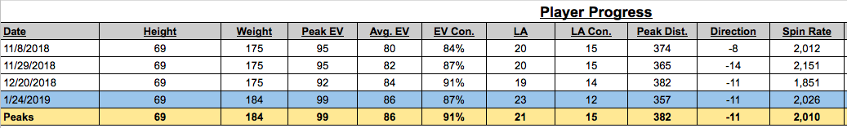

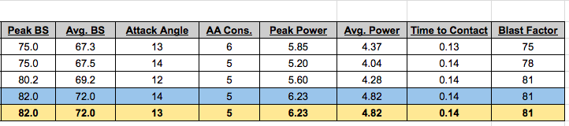

------------------

In addition to the raw batted ball and swing metrics listed above, we can give our players an in depth look at how those balls profile through a more “real life” lens in a more traditional language.

* Batted Ball Types:  Percentage breakdown of the different types of balls they hit.
  + Ground balls = <6 degrees
  + Line drives = 6-24 degrees
  + Fly balls = 25-49 degrees
  + Pop ups = 50+ degrees

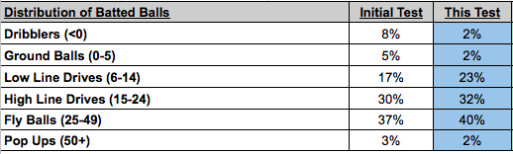

* Optimally hit balls:  Percentage breakdown of the four main things we can describe as optimal.
  + Hard hits = balls hit within top 10% of max exit velocity
  + Line drives = balls hit between 6 and 24 degrees
  + Hard hit line drives = balls within top 10% of max EV hit at 6-24 degrees
  + Deep balls = balls hit within 10% of player’s max distance

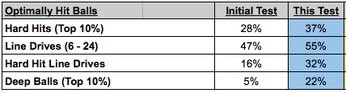

* Balls by field: Percentage breakdown of balls to the pull side, middle of the field, and opposite field.  Rapsodo’s exit direction allows us to sort this data.

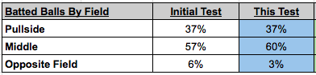

For the vast majority of our hitters, our focus is on increasing the percentages of hard-hit balls, line drives, and hard hit line drives.  Deep balls are only cited as a focal point if the player’s deep balls are going to do consistent damage at their level. With an understanding of the frequency that these outcomes take place, we are then able to look at the specifics on each of those outcomes and dive a little bit deeper.

The last graphic we look at is the spray chart that Rapsodo produces, which gives some context as to how far and which direction balls are being hit.  This is nicely color coded based on batted ball type can be an eye opener for some guys who think they are hitting “cage bombs” but in reality, are hitting mid-outfield fly ball outs.  This is a very simple way for hitters to visually evaluate the quality of their assessment round.

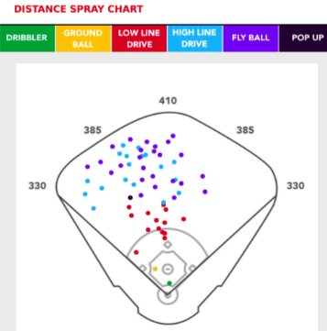

**Strike Zone Performance**

In addition to batted ball metrics, Rapsodo also provides us with information on where each ball is contacted with the strike zone (or outside of it).  This information paired with the batted ball info and our swing metrics gives us great insight into how each player performs inside the zone. We can break down metrics in a more general way (up, middle, down & in, middle, out) as well as get even more granular by looking at each of the nine zones specifically.  This information allows us to have hitters work on their weak zones in training, as well as highlighting their strengths and being able to build an approach around them.

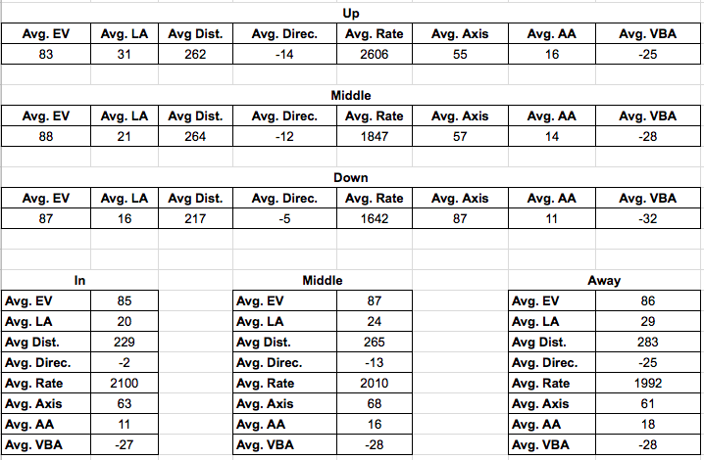

**Presenting the Information to Hitters: We are Working with Blast and Rapsodo to Develop Dayton Classics Specific Program Outlines to Share with Players and to Track Development each week and over every Training Session Timeframe**

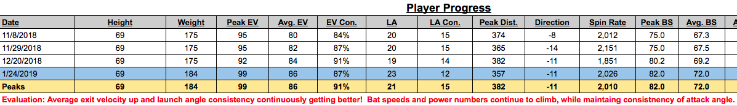

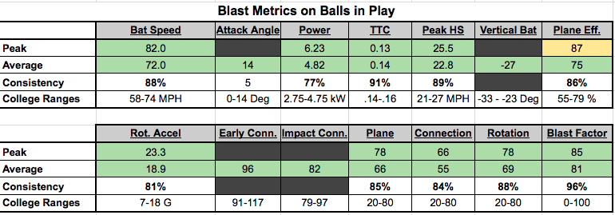

We also give the hitter a baseline on his performance using the Game Sense Pitch Recognition program, as we will utilize this software on a daily basis and we can specifically target and work to improve upon these numbers as well.  This progress is measured and tracked.